Flag 6a: Identifying riparian and pre-1914 water rights and assigning a priority date

Function Name: pre1914_riparian_priority

Data Source:

* ewrims_flat_file.csv

<https://intapps.waterboards.ca.gov/downloadFile/faces/flatFilesEwrims.xhtml?fileName=ewrims_flat_file.csv>

Existing Fields:

* EFFECTIVE_DATE: Effective date is the **date of status** of particular water right record. *Note: Upon reviewing the “eWRIMS flat file master” data, effective date is sometimes the same as “PRIORITY_DATE” but more often, not. This field is not useful for this tree.*
* PRIORITY_DATE: Date used by the Division to establish priority for water allocation during dry years and/or water shortages. Earlier dates indicate “seniority” when determining curtailment of specific watersheds.
* RECEIPT_DATE: Date that a water right is physically/electronically received by the Division’s Records Unit. SAME AS PRIORITY DATE *IF* NOT BLANK.
* APPLICATION_RECD_DATE: Date the application is physically received by the Division. Identical to “Receipt Date” field. SAME AS PRIORITY DATE *IF* NOT BLANK.
* APPLICATION_ACCEPTANCE_DATE: Date that the Division’s Permitting section determines the water right ID meets all acceptance criteria and begins processing the application
* WATER_RIGHT_TYPE: Water right type indicates the type of water record it is. Currently there are 18 different types of water right types to identify the water record. (Would indicate if “statement of div & use”)
* YEAR_DIVERSION_COMMENCED: Applies only to Statements of Water Diversion and Use. The year diversion first began, to the best of the submitter’s knowledge.
* SUB_TYPE: Applies only to Statements of Water Diversion and Use. Checkboxes used to identify diversion sub type(s). Selected subtypes viewable from user interface.

New Fields:

* RIPARIAN
* PRE1914
* ASSIGNED_PRIORITY_DATE

Generate three new fields:

“RIPARIAN” “PRE1914” & “ASSIGNED_PRIORITY_DATE”

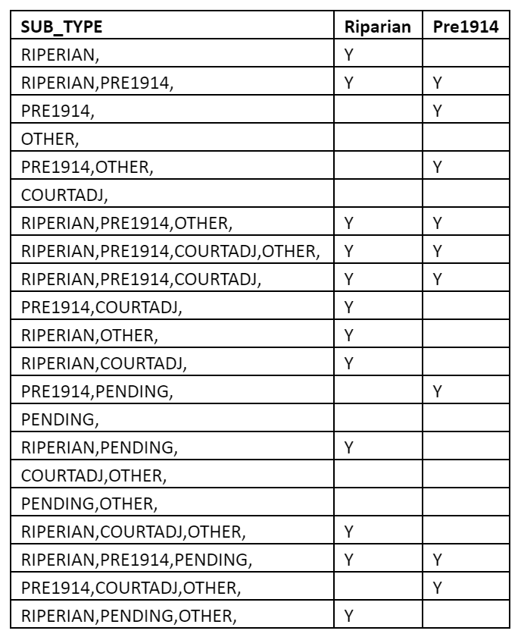

Update field “ASSIGNED_PRIORITY_DATE” = “value”0101 (Format YYYYMMDD)

Update field “ASSIGNED_PRIORITY_DATE”

= 10000000

Is there a reported “year_diversion_commenced”?

If “Sub_Type” is “RIPERIAN,PRE1914,” or “RIPERIAN,PRE1914,COURTADJ,OTHER,” or “RIPERIAN,PRE1914,OTHER,” or “RIPERIAN,PRE1914,COURTADJ,”

then Y in “Pre1914” and Y in “Riparian”

If “Sub_Type” is “PRE1914,” or “PRE1914,COURTADJ,”

then Y in “Pre1914” and N in “Riparian”

If “Sub_Type” is “RIPERIAN,” or “RIPERIAN,COURTADJ,” or “RIPERIAN,PENDING,OTHER,“ or “RIPERIAN,OTHER,“ or “” then Y in “Riparian” and N in “Pre1914”

Yes

No